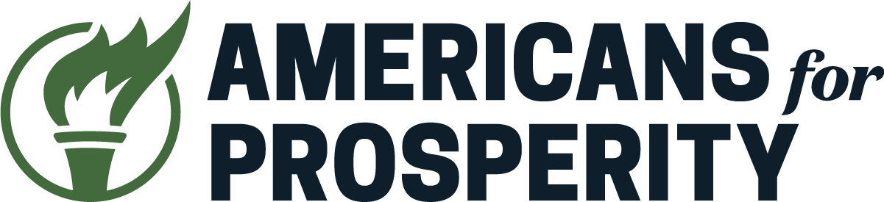

March 26th, 2025
Chair Capriglione and Members of the Committee,
My name is James Czerniawski, and I am the Senior Policy Analyst focused on issues surrounding Technology and Innovation at Americans for Prosperity. Thank you for providing us with the opportunity to share our perspective on HB 149, The Texas Responsible Artificial Intelligence Governance Act, today. The original version of this proposal, HB 1709, had a similar companion in the state of Virginia that was just vetoed by Governor Glenn Youngkin, noting that that particular legislation would “turn back the clock on Virginia’s economic growth, stifling the AI industry as it is taking off” and that “there are many laws currently in place that protect consumers and place responsibilities on companies relating to discriminatory practices, privacy, data use, libel and more.”
We appreciate and applaud Representative Capriglione’s efforts since introducing this legislation to incorporate modifications, removing many onerous and problematic provisions in the underlying legislation that were flagged by numerous groups, including ours. Particularly, we appreciate his narrowed focus on government use of the technology and the adverse impacts it may have on Texans.
However, we believe some problematic provisions remain in the current version before the committee and respectfully recommend they oppose moving forward with this legislation in its current form.
Notably, in Section 551.056, the legislation attempts have it both ways, trying to treat political viewpoint as a protected class while also simultaneously recognizing in Section 551.058 that disparate impact alone is not sufficient to demonstrate intent to discriminate. This would be an expansion of discrimination law in a way that also infringes on private actors’ first amendment rights of their own. In that same section, the legislation would bar social media companies from utilizing AI to engage in aspects of content moderation. While we understand the reasoning behind such a provision, it also opens the legislation to a legal challenge. In Moody v. NetChoice, the Supreme Court recognized that social media platforms, similar to alternative forms of media, are entitled to editorial discretion. This provision would run directly against this finding by the Supreme Court and needlessly create a situation where the state has to expend taxpayer money to defend a law that has such a problematic provision.
We understand the concerns around the content moderation choices of platforms, but a tangential case in Murthy v. Missouri showed where the energy around those concerns should be laser focused. In that case, we saw evidence of the government leveraging its position, resources, and power to pressure social media companies to take action on content. Mark Zuckerburg acknowledged this reality when it came to how the government pressured Facebook surrounding COVID 19 content. It is also worth noting that Facebook, Twitter, Google, and many companies have eased various policies over the last year around much of this in response to seeing the public’s reaction to their approach to content moderation.
Ultimately, the solution isn’t to focus on the platforms themselves, but rather the government and preventing it from doing such things ever again. Even Representative Capriglione’s amendments reflect this reality to a degree. President Trump correctly recognized this dynamic, and upon entering office, showed a more appropriate way to tackling this issue. He signed executive order, “Restoring Freedom of Speech and Ending Federal Censorship”, which set out a path to limit the government’s ability to engage in such dangerous behavior. In Congress, republicans introduced legislation that sought to serve as a legislative way of accomplishing what the President did via executive order. These pathways are more appropriate to explore when trying to tackle the issue that is being raised in these provisions, and belong in separate legislation altogether.
Texas has been a big winner in recent years, attracting tech companies and their investment away from California in part because it has a business-friendly climate. It stands to gain even more by having a light touch regulatory approach to emerging technologies. It’s no surprise that the first project announced with Project Stargate was planned here in Texas. However, if the state wants to continue building that momentum, that means it is critical the state gets this policy right.
We’ve seen proposals, like Right to Compute legislation in New Hampshire and Montana, and the learning laboratory and sandbox programs in Utah, which offer a more compelling path forward on Artificial Intelligence policy and proposals we are supportive of. Those proposals are light touch by design and constrain government overreach by forcing a narrowly tailored approach to regulation.
We stand ready to work with Representative Capriglione and other legislators to advance legislation that can meet the moment to solidify Texas’ status as a leader in emerging tech. I thank you for your time and look forward to your questions.

Sincerely,
James Czerniawski
Senior Policy Analyst, Technology and Innovation
Americans for Prosperity

