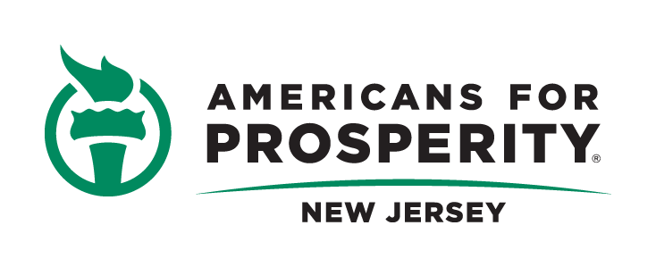
Testimony on Senate Bill S1707
Renewable Portfolio Standards
Senate Environment and Energy Committee
Monday, February 29, 2016
Chairman Smith and members of the Committee,
Thank you for the opportunity to speak today. My name is Mike Proto and I am the Communications Director of Americans for Prosperity’s New Jersey chapter. Americans for Prosperity is the largest free-market, grassroots organization in the nation with more than 103,000 activists across the State of New Jersey. Americans for Prosperity is dedicated to educating citizens on how free market policies lead to more New Jersey residents living their version of the American dream.
Likewise, Americans for Prosperity is a leading advocate for free-market policies in the energy sector in which all residents and small business alike have access to abundant, low-cost electricity. After all, affordable energy is the lifeblood of a strong, growing economy which provides greater opportunity, more jobs and ultimately higher wages for all New Jerseyans.
With this in mind, Americans for Prosperity has grave concerns about the devastating impacts Senate Bill 1707 would have on hard-working families in the years ahead. New Jersey’s current energy mandate, which requires New Jersey to get 22.5% of its electricity from renewable sources by 2021, is itself expected to inflict serious economic harm to the state and our job market. A study from the Beacon Hill Institute estimated that the current mandate will cost New Jersey citizens $1.05 billion in higher electricity prices and reduce employment by 11,365 jobs by 2021. By nearly quadrupling the State’s reliance on costly, inefficient alternative energy sources to 80% by 2050, the consequences for our economy and jobs will undoubtedly be even more devastating.
Concerns over the cost implications of this arbitrary mandate are heightened given data on residential electricity prices over the past five years. According to the Energy Information Administration (EIA), despite a 60% decline in the cost of natural gas and very little change in the price of coal, residential electricity prices have risen a staggering 34% from 2010 through October, 2015. There is only one logical conclusion as to why this has occurred: the doubling of the nation’s reliance on wind and solar (from 2.3% to 5%) during that time frame along with the Obama administration’s “War on Coal.” The Institute for Energy Research (IER) reports, for example, that “new gas plants are twice as expensive as existing coal plants and that new wind plants are 3 times as expensive.” Given the specific carve-out of 4.1% from solar by 2028 embedded in this mandate, the EIA data should set off alarm bells.
In addition to delivering skyrocketing electricity rates, such a dramatic increase in reliance on sources like wind and solar will threaten grid instability. Wind turbines and photovoltaic (PV) solar cannot respond to changes in demand the same way that natural gas or coal power plants can ramp up or down to meet demand. They are non-dispatchable technologies subject to weather changes that make it difficult to match electricity demand with supply. As a result, they must be backed by other sources. The hidden cost of having backup electricity generation is typically not considered when talking about the cost of wind and solar. Even with backup sources, the variability of wind and solar increases the chance of blackouts and brownouts and requires having excess backup generators raising the cost of electricity.
The proposed mandate does not even make sense if one cares about reducing carbon emissions. Electricity from nuclear power plants accounted for 19% of electricity generated in the U.S. in 2014. The combined electrical generation from wind, solar, biomass, and geothermal was only 7% and hydropower accounted for 6%. If this bill is about reducing carbon emissions, why is the most successful low carbon power source left out?
As an advocate for a free market in the energy sector, Americans for Prosperity supports ceasing the escalating meddling and cronyism in the energy sector if for no other reason than it does not work. Solar and wind have been heavily subsidized for decades and still the technologies are not competitive with traditional sources. In 2013, federal subsidies per unit of production were a whopping $231 per megawatt hour for solar and $35 per megawatt hour for wind. By contrast, coal and natural gas/petroleum received just $0.57 and $0.67, respectively. Such cronyism only serves to reward failure, hurt ratepayers and taxpayers, and impede the kind of innovation which could improve their viability in the energy marketplace. Simply put, it’s time for policymakers to end the mandates, subsidies and tax giveaways in the industry.
In closing, New Jersey’s citizens should not have to worry about rising electricity prices and the chance of blackouts. By tripling New Jersey’s current energy mandate, both of these concerns would become reality. Currently, no state has an electricity mandate even close to this level and this bill would lead New Jersey into uncharted and dangerous territory.
If lawmakers are concerned about decreasing poverty and increasing prosperity, they will reject the proposed RPS and instead embrace energy policies that will make it more affordable for New Jersey families to keep the lights on, heat their homes and run a business in the Garden State.
Mike Proto

Communications Director
Americans for Prosperity
Our mission: Americans for Prosperity exists to recruit, educate, and mobilize citizens in support of the policies and goals of a free society at the local, state and federal level, helping every American live their dream – especially the least fortunate.

http://www.beaconhill.org/BHIStudies/RPS/NJ/NJ-RPS-Study-BHI-Final-April2014.pdf
http://instituteforenergyresearch.org/analysis/history-of-solar-power/ 3 https://www.eia.gov/tools/faqs/faq.cfm?id=427&t=3
http://instituteforenergyresearch.org/analysis/eia-subsidy-report-solar-subsidies-increase-389-percent/

